Before you Start  Time  - Preparation: 15 minutes  - Instruction: 90 minutes  Place  - Computer lab  Advanced Preparation  - Install Acrobat Reader from www.get.adobe.com/reader.  - Install Microsoft Photo Story from  www.microsoft.com.  - Download Bird Island PR interactive PDF from CB wiki.  - Make the interactive PDF and Photo Story accessible on student computers and test them prior to presenting the lesson to students.  Materials  - Bird Island PR Interactive PDF  - Print copies of the worksheet titled:  Bird Island Puerto Rico  Exploring Ways to Research Biodiversity  - Print Photo Story Hints (optional)  - A-V Equipment:  - LCD Projector  - Screen or Whiteboard  - Digital Camera  - Computers  - Acrobat Reader  - Microsoft Photo Story (optional)  ICT  - Interactive PDF map  Low-Tech or No-Tech Option  - Print the Bird Island PR PDF with Elfin-Woods Warbler and Roads layers checked. Print another copy with only the elevations checked.  - Print summaries of each bird species (found on the PDF map) from: http://neotropical.birds.cornell.edu/portal/species.  http://www.allaboutbirds.org/guide/search.  • Print summaries of each ecoregion (found on the PDF maps) after locating them on the website:  http://worldwildlife.org/science/wildfinder.  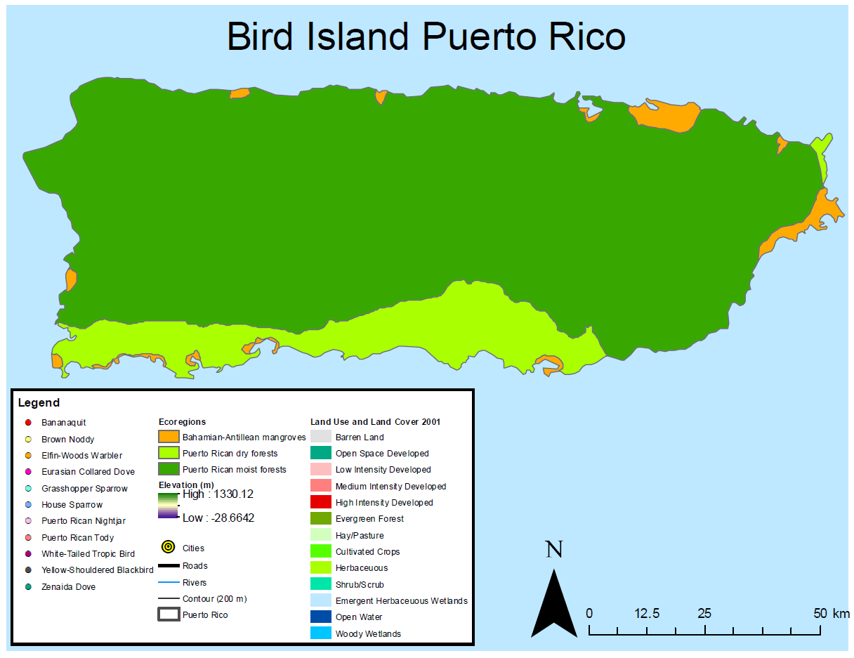Figure 1. Bird Island Puerto Rico.  Figure 2. Layers button in Acrobat Reader's left-hand panel.  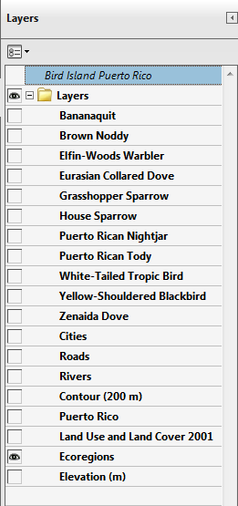 Figure 3. These layers should be  turned on for step 2a.  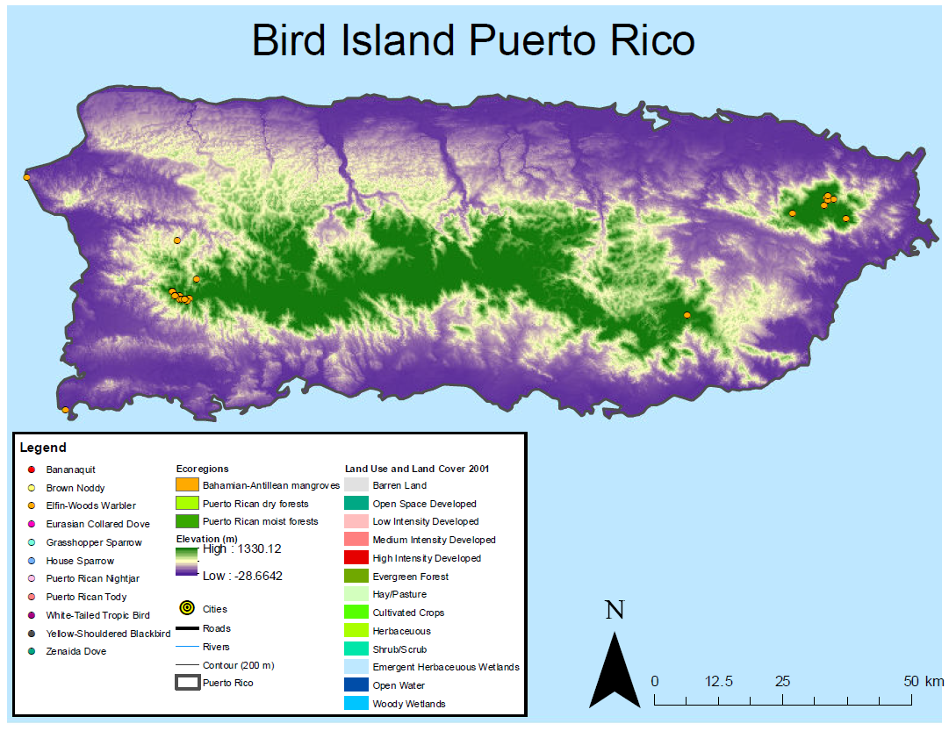 Figure 4. Bird Island Puerto Rico Map Showing Roads, Ecoregions and a Bird Species in Step 2b.  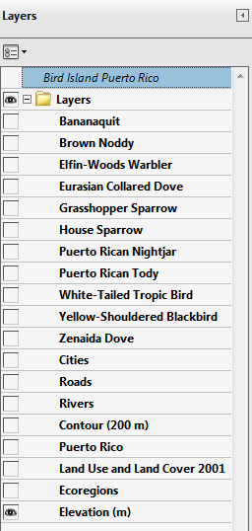 Figure 5. These layers should be  turned on for step 2b.  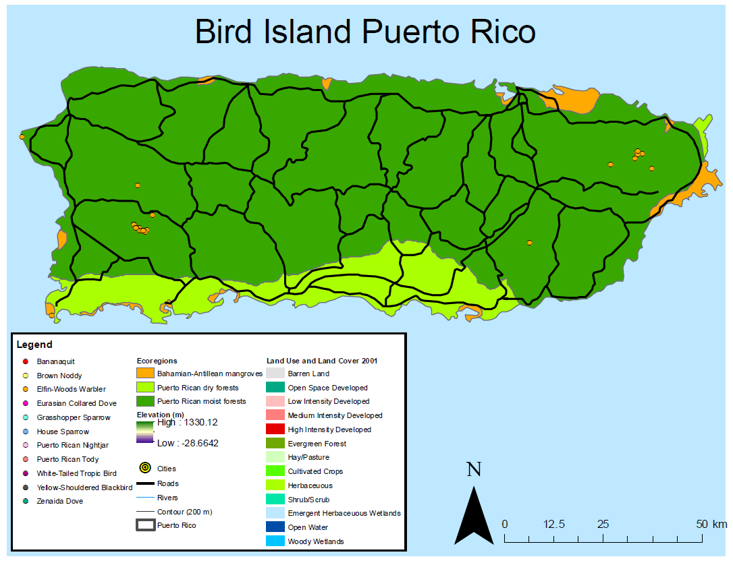 Figure 6. Map with Roads, Elevations and a Bird Species in Step 4a.  About Adaptation  “All organisms need to adapt to their habitat to be able to survive. This means adapting to climatic conditions of the ecosystem, predators, and other species that compete for the same food and space.” (WWF)  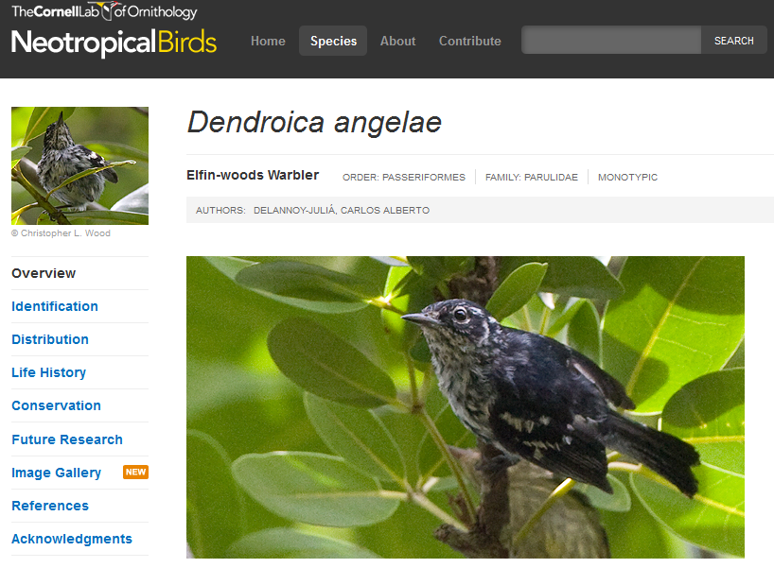Figure 7. Cornell University’s Neotropical Birds Website.  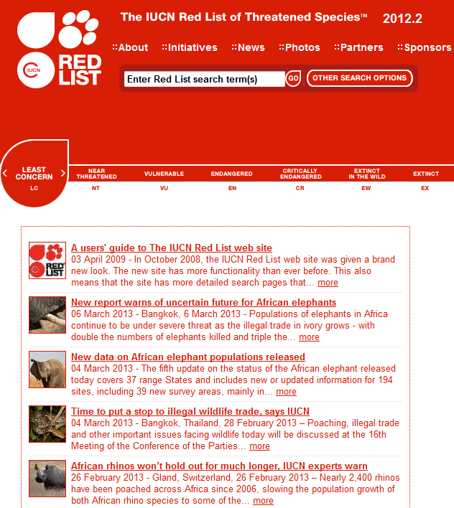Figure 8. IUCN Red List Website.  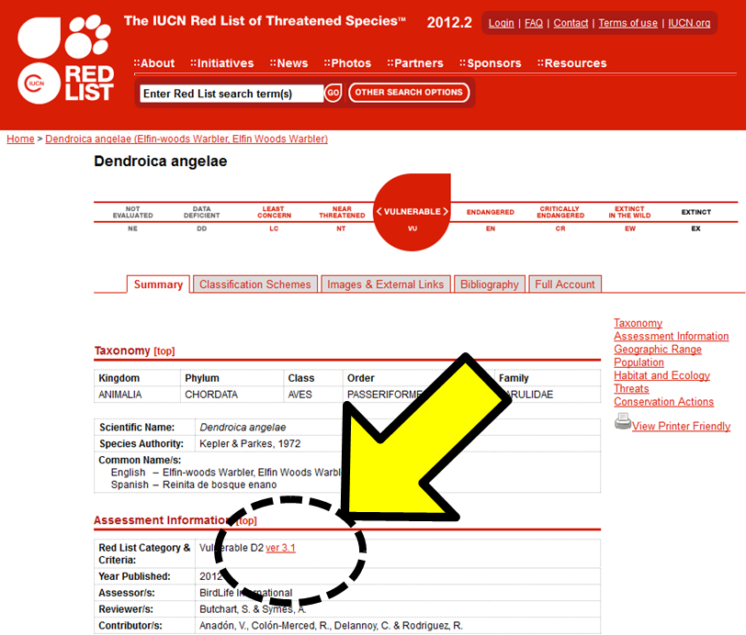Figure 9. Extinction Classification Link on the IUCN Red List Website.  Examples of  Conservation Classifications  EX (extinct) No reasonable doubt that the last individual has died.  EW (Extinct in the wild) Known only to survive in captivity.  CR (Critically Endangered) Extremely high risk of extinction in the wild.  EN (Endangered) Very high risk of extinction in the wild.  VU (Vulnerable) High risk of extinction in the wild.  NT (Near Threatened) Close to being threatened in the near future.  LC Least Concern) Widespread and abundant.  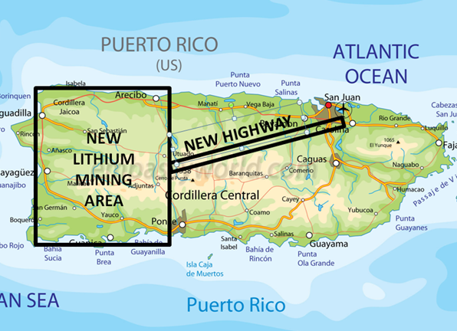  Figure 10. Proposed Developments in Step 8. | Purpose  To explore biodiversity concepts by relating distribution of selected Puerto Rican bird species to species-specific adaptations and environmental attributes.  Overview  Students will use spatial data and web resources to explore connections between adaptations, habitat requirements, and distribution of selected bird species in Puerto Rico.  Essential Questions  - Why does distribution of bird species vary across ecoregions?  - How do the adaptations of each species relate to its distribution?  Learning Objectives  Students will be able to:  - Define and understand the meaning of biodiversity-related terms.  - Research habitat requirements of bird species.  - Explain species distributions based on analysis of ecoregion attributes and species-specific characteristics.  - Synthesize multimedia resources and develop public service announcements.  Key Concepts  - Ecoregion  - Habitat  - Ecological Niche  - Adaptation  - Endangered Species  - Human impact  - Map Interpretation  - Public Service Announcement  Investigation Overview  1. Discover the concept of “ecoregion.”  2. Begin familiarizing students with the Bird Island Puerto Rico PDF.  3. Discover the concept of “habitat.”  4. Explore the habitat of a selected bird species in Puerto Rico.  5. Introduce the concept of “ecological niche.”  6. Explore ways to research and assess biodiversity.  7. Assess potential impacts of proposed development on selected bird species.  - Conducting student research  - Student presentations  - Debrief and discuss the experience  Conducting Biodiversity Research  - Discuss the concept of “ecoregion.”  - Engage students in a discussion about ecoregions.  Ask students: What is an ecoregion?  - Encourage students to break the word “ecoregion” into two parts, “eco” and “region.”  - “eco” means environment  - “region” means an area with boundaries  - Write a class definition of ecoregion on the board using student-generated ideas.  Ask: How could we revise our class definition of ecoregion (that is written on the board)?  • A large unit of land or water containing a geographically-distinct set of species, communities, and environmental conditions (WWF).  - Begin familiarizing students with the Bird Island Puerto Rico PDF.  - Project your computer’s desktop onto a screen, whiteboard, or smartboard to show the Bird Island Puerto Rico map (Figure 1) and click the “Layers” button (Figure 2) in the left-hand panel of Acrobat Reader. (If you don”t see it, right-click in the left-hand panel of Acrobat Reader and select “Layers”). Be sure the layers that are checked and unchecked match Figure 3. Have students perform the same task.  Ask students:  i. Looking at the map, what are the three ecoregions of Puerto Rico called? (Ask students to record their answer on page 1 of their Worksheet)  • Puerto Rican Dry Forests  • Puerto Rican Moist Forests  • Bahamian-Antillean Mangroves  ii. Looking at the map, why do some areas of the island contain dry forest ecosystems and some contain moist ecosystems? (Ask students to record their answers on page 1 of their Worksheet)  • Dry Forest Ecoregion – low elevation, sandy beach soils, sunshine and high winds.  • Moist Forest Ecoregion– rich soils due to moist trade winds traveling up the high elevations and releasing moisture (also known as orographic lifting).  - Uncheck the “Ecoregions” layer and then check the “Elevation” layer to explore how the ecoregions relate to elevation.  - Discuss the concept of habitat.  - Engage students in a discussion about habitats.  Ask: What is a habitat?  - Write a class definition of habitat on the board using student-generated ideas.  Ask: How could we revise our class definition of habitat? (Ask students to record their answer on page 2 of their Worksheet)  • “The place or environment where plants or animals naturally (or normally) live and grow” (National Geographic Society).  - Have students brainstorm basic survival needs that habitats provide for animals.  Ask: What are some things inside a habitat that allow animals to survive inside their habitat?  • Food  • Water  • Shelter (from weather and predators)  • A place to raise young  - Explore the habitat of a bird species in Puerto Rico.  - On the Bird Island Puerto Rico map, turn on the “Ecoregions,” “Roads” and “Elfin-Woods Warbler” layers (Figure 6).  Ask: What are some features of the habitat of the Elfin-Woods Warbler? (Ask students to record their answer on page 2 of their Worksheet)  • Moist forest  • High elevation  • Away from cities and roads  5. Introduce the concept of “Ecological Niche.”  Ask: What does the term “Niche” in the phrase “Ecological Niche” mean in French? (Ask students to record their answers on page 2 of their Worksheet)  • In French, niche means nest.  • In ecology, niche refers to the role played by an organism in its ecological community. For example, the Elfin-Woods Warbler lives in highland woods in Puerto Rico and feeds on insects such as tree ants.  6. Explore ways to research and assess biodiversity.  - Project your computer’s desktop onto a screen, whiteboard, or smartboard and use the internet browser to go to Cornell University’s Neotropical Birds website (figure 7). http://neotropical.birds.cornell.edu/portal/species  - Find information for the “Elfin-Woods Warbler” by typing the name into the search bar.  - Instruct students to perform the same task.  - Set the scene for a practice research investigation of a bird and its habitat needs in Puerto Rico.  Tell students:  - We are a wildlife biologists hired by the Puerto Rican government to research local bird species.  - Government officials have been approached by industry seeking authorization to develop a large resort for tourism in a corner of the western mountains.  - The officials ask you to assess potential impacts to the Elfin-woods Warbler bird population before allowing any development.  - Discuss the first steps to take in order to assess impacts of the proposed development on selected bird species in Puerto Rico.  Ask students:  - As biologists evaluating potential impacts on any particular bird species, what do we need to know first?  • Characteristics of the ecoregion  • Habitat requirements of the bird species  - Remember that the Elfin-woods Warbler lives far from roads. What does this suggest about its habitat needs? (Ask students to record their answers on page 2 of their Worksheet)  - The bird requires forests and undeveloped land with little contact with humans.  - Reading the Cornell website, what do you notice about the bird’s physical characteristics and what it prefers to eat? (Ask students to record their answers on page 3 of their Worksheet)  - The body size is small.  - This small size allows it to hover in trees and capture insects (an example of adaptation).  f. Project your computer’s desktop onto a screen, whiteboard, or smartboard and use the internet browser to go to the International Union for Conservation of Nature (IUCN) website (figure 8). http://www.iucnredlist.org  g. Instruct students to find information for the “Elfin-woods Warbler” by typing the name into the search bar.  Ask students:  - On the IUCN website, locate the section entitled Assessment Information (2nd section). Find the “Red List Category & Criteria” in this section and click the link at the end of that line.  - What does the term extinct mean? According to the IUCN website, is the bird considered a critically endangered (CE), endangered (EN), or vulnerable (VU) species? (Ask students to record their answers on page 3 of their Worksheet)  • “…when there is no reasonable doubt that the last individual has died.” (IUCN)  • Classified as VU (vulnerable).  ii. What are the differences between the CR, EN, and VU classifications? Record your answers on page 3 of your Worksheet.  • CR – a species facing an extremely high-risk of extinction in the wild  • EN – a species considered to be facing a very high risk of extinction in the wild  • VU – a species considered to be facing a high risk of extinction in the wild  (Write on the blackboard)  h. Drawing conclusions  Ask students:  Given what we now know about the proposed tourism resort and the Elfin-Woods Warbler’s characteristics, ecoregion and habitat, can we as wildlife biologists support the development?  • No legal protection required for VU species.  (endangered species triggers protection)  • Some birds may be displaced.  • No significant impact to the Warbler species.  • Overall the plan is feasible and could be supported.  7. Assessing Impacts to a Bird Species as a Wildlife Biologist.  a. Divide students into 6 groups.  b. Assign each group a bird species from the PDF map.  c. Distribute Photo Story Hints handout.  d. Hand digital camera to a group.  Inform the students:  i. It is now time to use the tools and process you have learned to assess the potential impact to another bird species.  ii. Industrial developers propose to clear-cut forests and strip mine much of one-third of the western end of the island from Mayaguez to Utoado to mine lithium metal for use in cell phones.  iii. A major highway is also proposed that would cross the island to allow for deliveries to San Juan airport.  iv. The Puerto Rican government has asked you to evaluate potential impacts of this proposed development on the local bird populations.  v. Working as a team of wildlife biologists, use the worksheet (starting on page 4) to help you determine whether or not to support the development of this strip mine in Puerto Rico.  vi. After finishing your research, develop a Public Service Announcement using Photo Story to explain your decisions.  - Conducting student research  i. Support students as necessary  ii. Provide specific deadlines for completing various parts of the investigation and Photostory development.  - Student presentations  i. Have each student group present their results using Photo Story to the class.  ii. Encourage other students to ask questions after each group presents.  - Debrief and discuss the experience.  i. Which groups decided they could not support this project?  ii. Which groups decided they could support this project?  iii. What should our decision be as a class?  iv. So now imagine that the Puerto Rican government has decided to move forward with the strip mine.  - What recommendations would you make in terms of limiting the environmental impacts of this development?  - Are there areas within this third of the island that you would recommend protecting and leaving undeveloped?  - Which species will be most impacted?  - Which species will be least impacted?  v. Can you think of some other ways that scientists would use maps like this to make conservation-related decisions?  iv. How would you describe the process of making your decision? What was challenging?  v. Can you think of some other ways that scientists would use maps like this to make conservation-related decisions?  This material was developed through the Crossing Boundaries Project (http://crossingboundaries.org) with support by the National Science Foundation under Grant No. 0833675. Any opinions, findings, and conclusions or recommendations expressed in this material are those of the authors and do not necessarily reflect the views of the National Science Foundation.

