Before you Start  Time  - Preparation: 15 minutes  - Instruction: 90 minutes  Place  - Computer lab  Advanced Preparation  - Download National Geographic "Biodiversity" video from CB wiki.  - Install Acrobat Reader from www.get.adobe.com/reader.  - Download Bird Populations on Bird Island interactive PDF from CB wiki.  - Make this interactive PDF accessible on student computers and test it prior to presenting the lesson to students.  Materials  - National Geographic "Biodiversity" video  - Bird Populations on Bird Island Interactive PDF  - Newsprint (12 sheets)  - Tape  - A-V Equipment:  - LCD Projector  - Screen or Whiteboard  - Computers  - Acrobat Reader  ICT  - Interactive PDF map  Low-Tech or No-Tech Option  - Print and/or photocopy the Bird Populations on Bird Island PDF for use as handouts  Ecological Society of America’s definition of biodiversity  “Biodiversity includes all organisms, species, and populations; the genetic variation among these; and all their complex assemblages of communities and ecosystems.  - Genetic diversity is all the different genes contained in all individual plants, animals, fungi, and microorganisms.  - Species diversity is all the differences within and between populations of species, as well as between different species.  - Ecosystem diversity is all the different habitats, biological communities, and ecological processes as well as variation within individual ecosystems.”  (http://www.esa.org/education_diversity/pdfDocs/biodiversity.pdf)  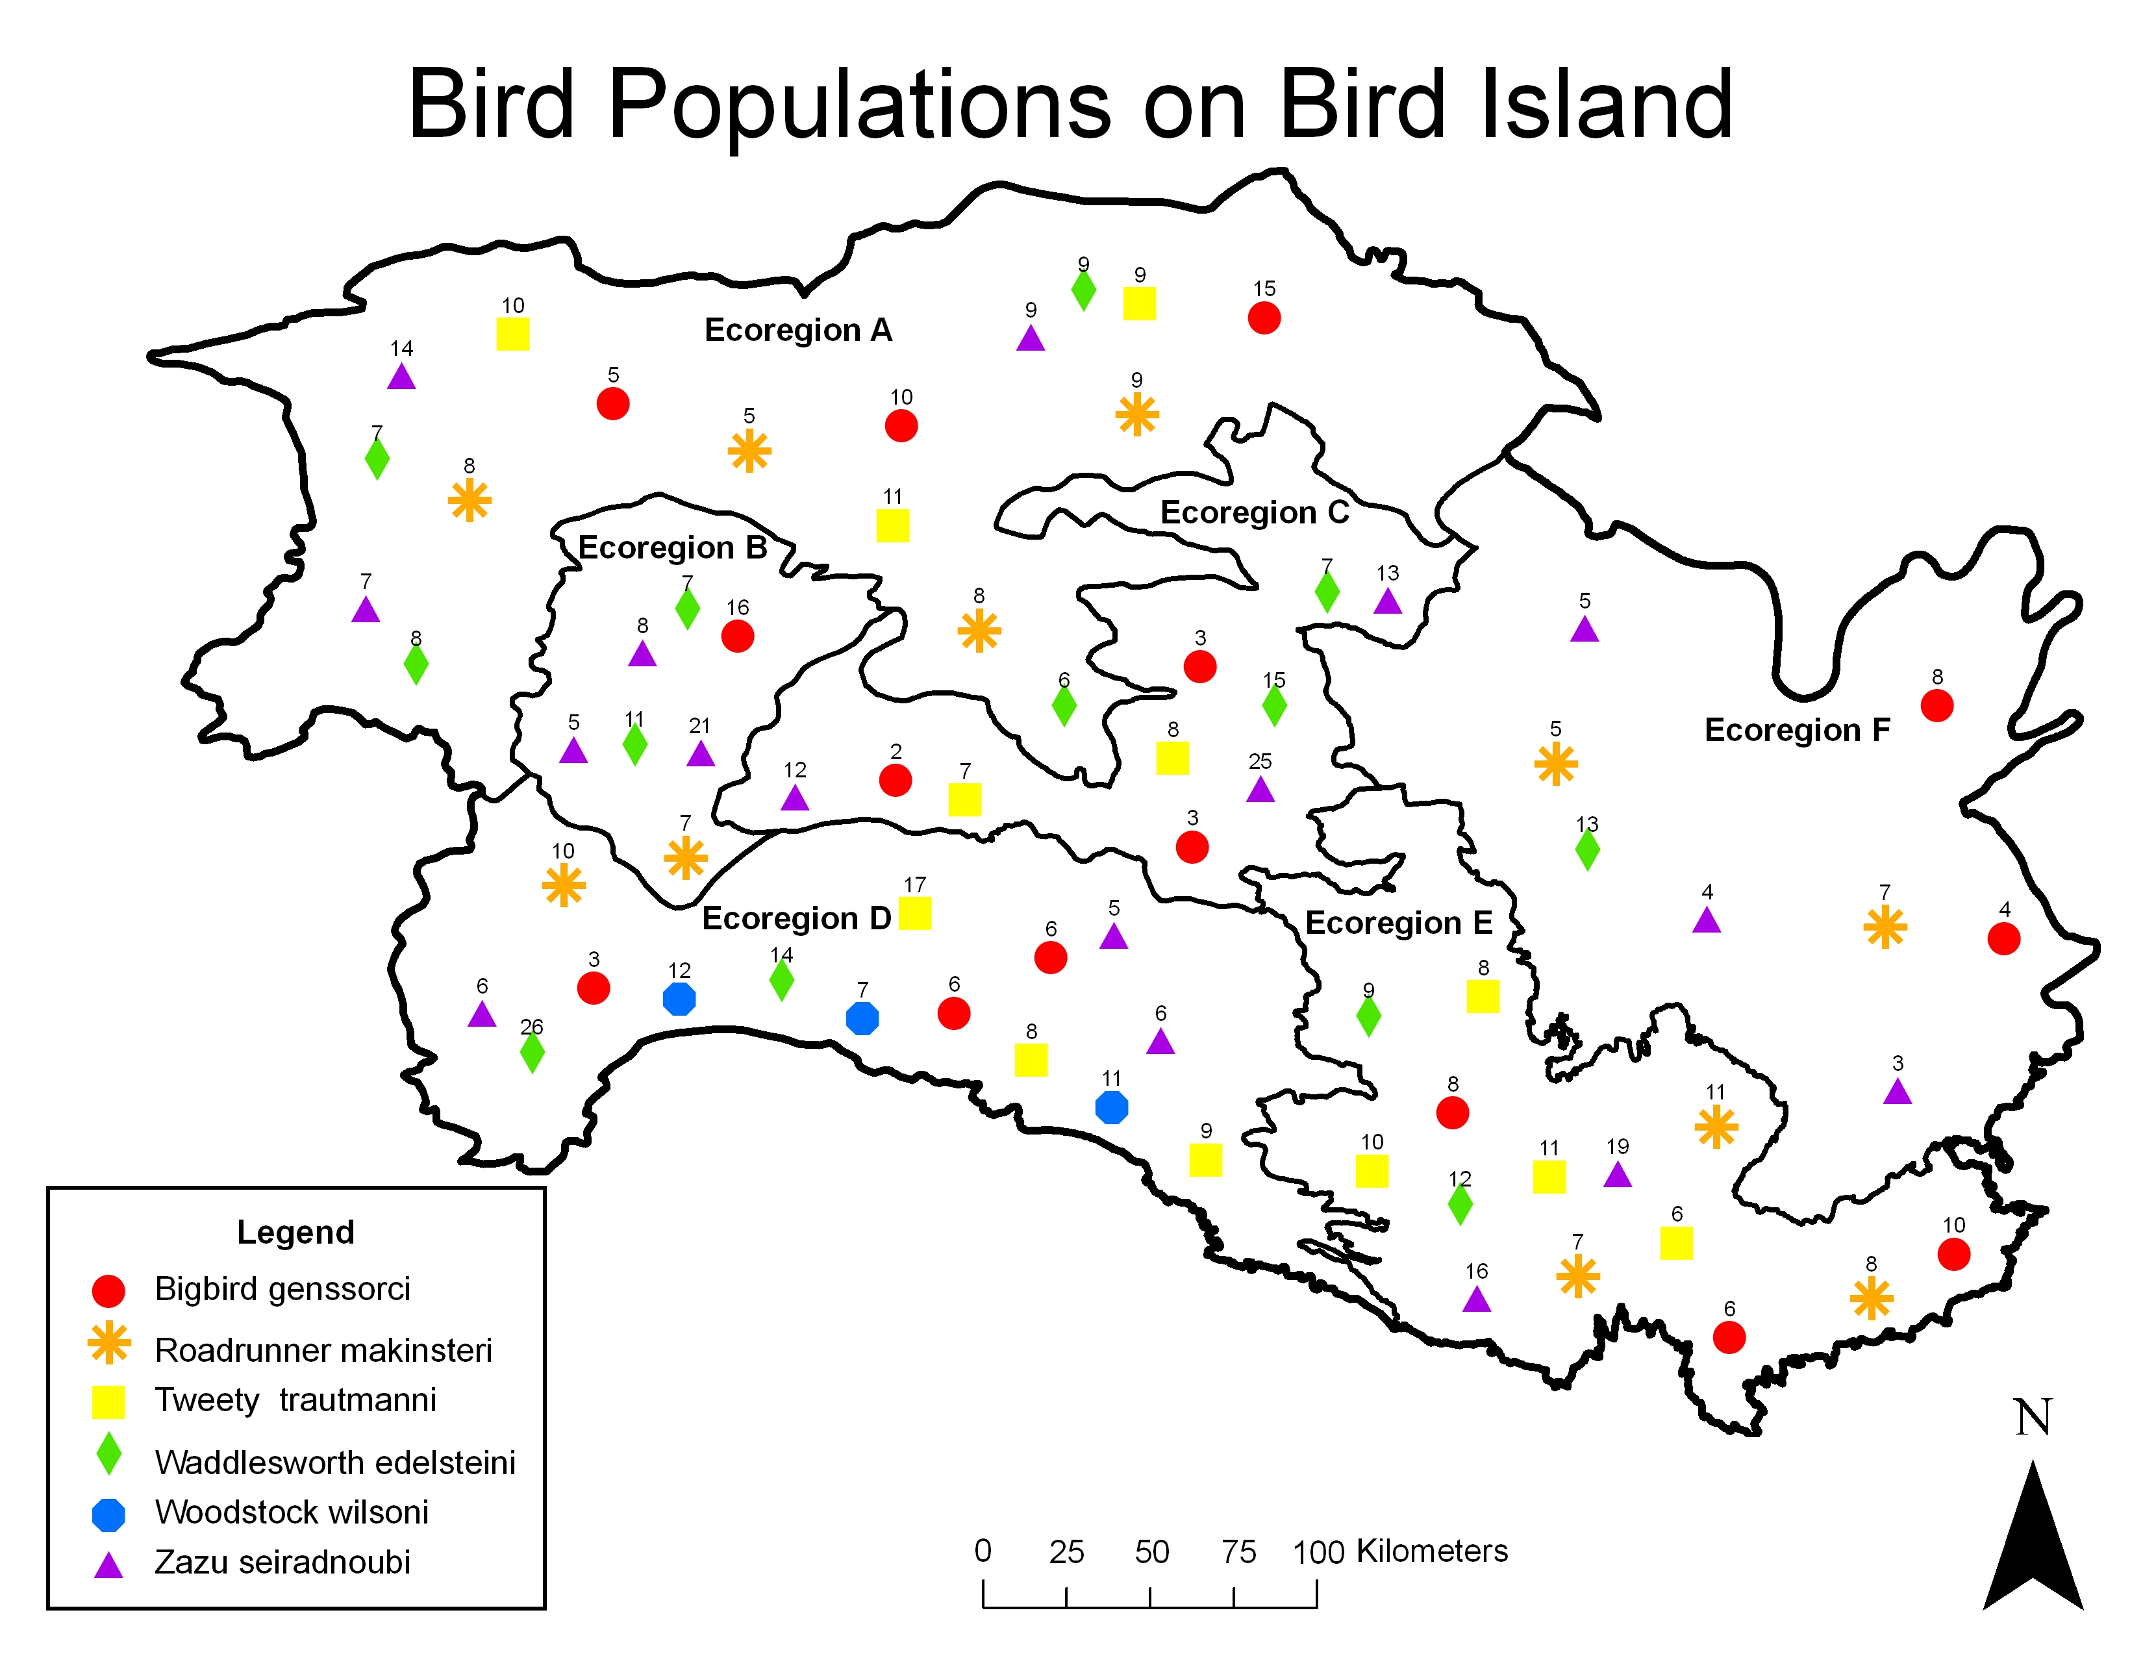  Figure 1. Bird Populations  on Bird Island.  Figure 2. Layers button in Acrobat Reader's left-hand panel.  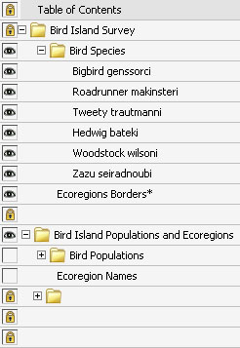  Figure 3. These layers should be  turned on for step # 2a.  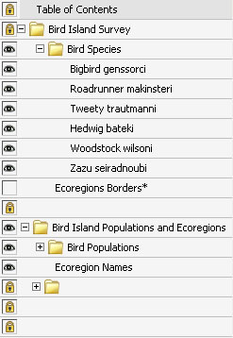  Figure 4. These layers should be  turned on for step #2ci.  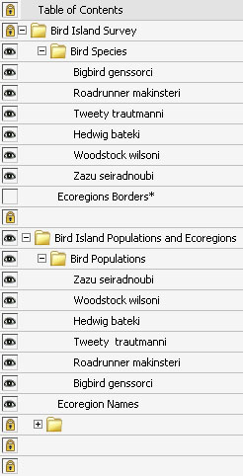  Figure 5. These layers should be  turned on for step #2cii and after.  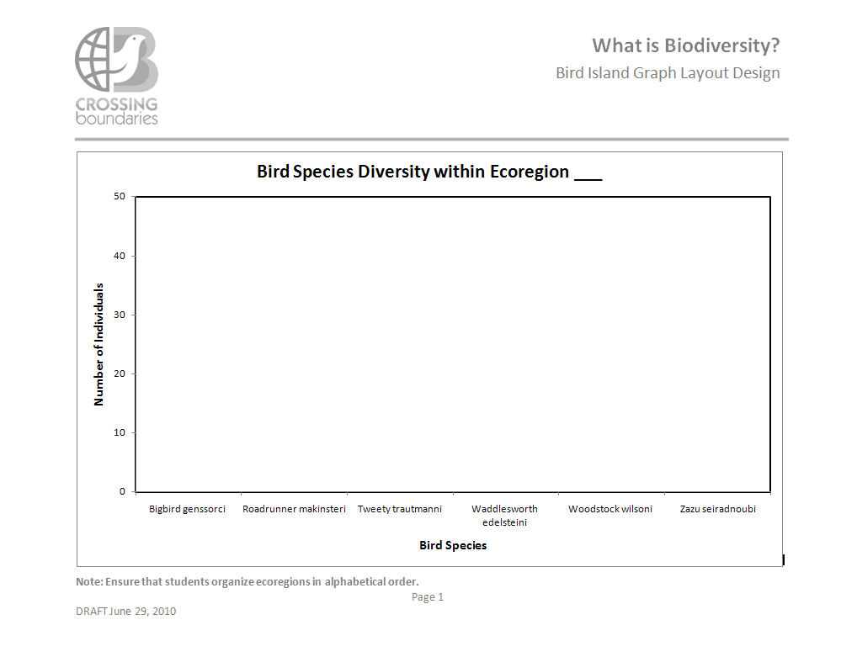  Figure 6. Bird Island Graph Layout Design.  Key vocabulary:  - Species Richness: # species in a geographic area  - Abundance: # individuals in a species within a defined area  - Evenness: Extent to which # species is similar across multiple geographic areas  Key Concept:  - Endemic species: a species that is found only in a single geographic area | Purpose  To define “biodiversity” and explore various methods of representing this concept.  Overview  Students will develop operational definitions of biodiversity and related terms through spatial and graphical analysis of fictional bird populations.  Essential Questions  - What is biodiversity?  - In what ways can we represent biodiversity?  Learning Objectives  - Students will be able to define and understand the meaning of biodiversity and related terms.  - Students will be able to identify and use appropriate terms to describe biodiversity.  Key Concepts  - Biodiversity  - Species richness  - Endemism  - Endemic species richness  - Abundance  - Evenness  - Graphing  - Map interpretation  Investigation Overview  - Discover the concept of biodiversity.  - Explore ways to represent and compare biodiversity.  - Graph abundance of all species within individual ecoregions.  - Discuss these single ecoregion bar charts.  - Graph abundance of each species across all six ecoregions.  - Discuss these cross-ecoregion bar charts.  - Discuss ways to assess and compare biodiversity.  Conducting the Investigation  - Discover the concept of biodiversity.  - Engage students in a discussion about biodiversity.  Ask: What is biodiversity?  - Encourage students to break the word “biodiversity” into two parts, “bio” and “diversity.”  - “Bio” means life  - “Diversity” means variety  - Write a class definition of biodiversity on the board using student-generated ideas.  - Present the National Geographic “Biodiversity” video.  - Lead a discussion about the portrayal of biodiversity in this video.  Ask students:  - How does the video represent biodiversity?  - A variety of animals  - What might be missing in this definition?  - Plant diversity  - Microorganism diversity  - Ecosystem diversity  - Genetic diversity  - Humans as a part of Earth’s biodiversity  - How could we revise our class definition of biodiversity (that is written on the board)?  - “Biodiversity includes all organisms, species, and populations; the genetic variation among these; and all their complex assemblages of communities and ecosystems” (Ecological Society of America).  - Explore ways to represent and compare biodiversity.  - Project your computer’s desktop onto a screen, whiteboard, or smartboard to show Bird Populations on Bird Island map (Figure 1) and click the layers button (Figure 2) in the left-hand panel of Acrobat Reader. (If you don’t see it, right-click in the in the left-hand panel of Acrobat Reader and select “layers”). Be sure the layers that are checked and unchecked match Figure 3.  - Set the scene for an investigation of bird diversity on Bird Island.  Tell students:  - A group of scientists recently returned from surveying Bird Island, a remote island in the Atlantic Ocean. This island is inhabited by people.  - The scientists identified six species of birds living on the island.  - Here is a map they created after surveying the island. (Scientists recorded GPS coordinates for each of the bird populations they observed on the island).  - Each population of birds is shown as a unique symbol on the map and indicates a sampling site.  - Discuss the first steps to take in order to compare and assess bird diversity on the island.  Ask students:  - What would you need to do to be able to compare the diversity of bird species on Bird Island?  - Divide Bird Island into smaller areas to make it easier to compare different types of ecosystems on this island. Count the number of birds within each of these areas. [Be sure to match layers to figure 4].  (Scientists have classified all land on Earth into “ecoregions,” each of which represents a distinct assemblage of species and natural communities).  - Looking at the map, how many ecoregions are on Bird Island? [Be sure to match layers in figure 5].  - 6 ecoregions  - How could you compare one ecoregion to another?  - Count the number of species present in each ecoregion.  (This is called species richness).  - Count the number of individuals within each species in an ecoregion.  (This is called species abundance).  - Graph abundance of all species within individual ecoregions.  - Divide students into 6 groups.  - Assign each group to graph one ecoregion (A – F).  - Instruct students to open Bird Populations on Bird Island.  - Demonstrate the PDF map of Bird Populations on Bird Island.  - Identify the layers tab in the table of contents.  - Turn the layers on and off using the eye icon. (Folders must be activated for subsequent layers to be turned on and off).  - Show that the species icons and population numbers are located in different folders.  - Use the legend to determine species.  - Distribute a sheet of newsprint to each group.  - Instruct students to draw a bar chart on their newsprint that describes the total population of each bird species in their ecoregion. (Optional: draw a sample graph on the board with an unlabeled x and y axis. Refer to Bird Island Graph Layout Design shown in figure 6).  - Ask students:  - How will you label the x-axis?  - Bird species  - How will you label the y-axis?  - Number of individuals in each species  - Encourage students to color code each bar with the same color shown in the map’s legend. For example: the bar for Tweety trautmanni should be drawn in yellow.  - Remind students to create space for a column for each bird species present on the entire island even if that will result in empty columns for species not found in their ecoregion.  - Have students tape their bar chart on the board when finished.  - Discuss these single ecoregion bar charts.  - Lead a discussion about species distribution among ecoregions.  Ask students:  - What similarities or differences do you notice among ecoregions?  - Ecoregions A and F have a similar number of individuals within each species.  Do you know what this is called? We describe the number of individuals as “abundance.” Ecoregions A and F have species with relatively equal abundance. The other ecoregions show greater variability in species abundance.  - Ecoregion D has the highest number of species.  Do you know what this is called? We describe this as high species “richness.”  - Why might some ecoregions have more species than others?  - Habitat preferences or needs  - Availability of food resources  - Size of ecoregion  - Terrain of ecoregion  - Development of ecoregion  - Others?  - Graph abundance of each species across all six ecoregions.  - Assign each group of students one bird species to graph across all six ecoregions.  - Bigbird genssorci  - Roadrunner makinsteri  - Tweety trautmanni  - Hedwig bateki  - Woodstock wilsoni  - Zazu seiradnoubi  - Distribute a new sheet of newsprint to each group.  - Instruct students to draw a bar chart on their newsprint that describes the total populations of their assigned bird species in each of the ecoregions. (Optional: draw a sample graph on the board with an unlabeled x and y axis. Refer to Bird Island Graph Layout Design shown in figure 6).  Ask students:  - How will you label the x-axis?  - Ecoregions  - How will you label the y-axis?  - # Individuals  - Remind students to create one column for each ecoregion on Bird Island even if their assigned bird species is not present in an ecoregion.  - Have students tape their bar chart on the board when finished.  - Discuss these cross-ecoregion bar charts.  - Lead a discussion about species distribution across ecoregions of Bird Island.  Ask students:  - What similarities or differences do you notice among bird species on Bird Island?  - Woodstock wilsoni is present only in Ecoregion D. [Turn species on and off in the table of contents of the PDF to show the distribution of species].  Do you know what a species is called when it is only found in one ecoregion? An “endemic species “  - Why might Woodstock wilsoni be endemic to Eocregion D?  - Habitat preferences or needs: it lives only along the shoreline.  - Availability of food resources: it might depend on a species of fish that lives along the shoreline of Ecoregion D.  - Others?  - Discuss ways to assess and compare biodiversity.  - Lead a classroom discussion on the importance of measuring biodiversity.  Ask students:  - Why would these methods of representing biodiversity be important for scientists or researchers?  - To determine which ecoregions have the greatest variety of flora and fauna  - To determine which ecoregions have the greatest number of unique flora and fauna  - To relate diversity to stability of the ecoregion  - To identify what factors influence populations  - Why would these methods of representing biodiversity be important for policy makers or politicians?  - To protect or prioritize ecoregions for conservation and preservation efforts  - To restrict access to ecoregions with particularly sensitive flora and fauna  - Why would these methods of representing biodiversity be important for tourists? (Which ecoregions would you want to visit on Bird Island, and why?)  - Ecoregions with the greatest variety of birds  - Ecoregions with endemic birds
 | This material was developed through the Crossing Boundaries Project (http://crossingboundaries.org) with support by the National Science Foundation under Grant No. 0833675. Any opinions, findings, and conclusions or recommendations expressed in this material are those of the authors and do not necessarily reflect the views of the National Science Foundation.

