Before you Start  Time  - Preparation: 30 – 90 minutes  - Instruction: 60 minutes  Place  - Computer lab  Advanced Preparation  - Install Google Earth Pro version 5 or greater from www.earth.google.com.  - Download A Bird’s Eye View of Changing Landscapes Google Earth Tour from CB wiki.  - Select a location for your local investigation (e.g. school expansion, new big box store, or landfill) and create a placemark using the pushpin icon located in upper toolbar. Save your local placemark to the tour folder.  - Make Google Earth tour accessible on student computers.  - Test Google Earth and explore tour.  - Prepare 3 copies of Identifying Landscape Changes worksheet (full and/or compact version) for each student.  Materials  - A-V Equipment:  - LCD Projector  - Screen or Whiteboard  - Computers  - Google Earth Pro Version 5 or greater  - Internet connection  ICT  - Satellite Imagery  - Google Earth  Low-Tech or No Tech Option  - Print and/or distribute  A Bird’s Eye View of Changing Landscapes PowerPoint presentation for use in place of the Google Earth tour.  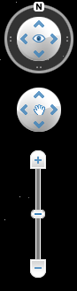  Figure 1. Navigation Tools  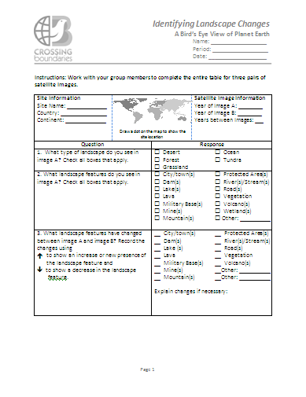  Figure 2. Identifying Landscape Changes Worksheet  Figure 3. Historical imagery button in Google Earth.  Table 1. T-chart.  Google Earth Tip 1: Use Google Earth’s vertical exaggeration and altimeter to explore changes in elevation.  - Check (click on) the terrain layer in the table of contents of Google Earth (Figure 4).  - Turn on vertical exaggeration (Tools→ Options→ Elevation Exaggeration: 3).  - Move mouse over a “mountain” to compare the mountain elevation to neighboring areas. The elevation will show on the altimeter along the bottom of the screen.  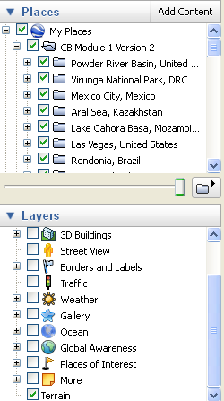  Figure 4. Terrain Layer  Worksheet Hint: An arrow pointing up (⬆) indicates an increase in the landscape feature or that it appeared in the recent image and an arrow pointing down (⬇) indicates a decrease in the landscape feature.  Google Earth Tip 2: Use the ruler tool, located in Google Earth’s tool bar (Figure 5), as a way to quantify landscape change. For example, students could compare changes in the length of a road or the surface area of a city using the ruler tool.  Figure 5. Ruler Tool. | Purpose  To analyze landscape change over time and infer how these changes might affect plant and animal communities.  Overview  Students will discover various ways in which landscapes change over time by analyzing patterns in current and historical satellite images from locations around the world.  Essential Question  How do landscapes change over time and how might these changes affect plant and animal communities?  Learning Objectives  - Interpret landscape changes as documented by satellite imagery.  - Make inferences about the causes of change and likely effects on plant and animal communities.  Key Concepts  - Human impact  - Landscape change (and resulting habitat change)  - Population growth  - Deforestation  - Agriculture  Investigation Overview  - Use satellite imagery to investigate landscape change over time at a location of interest within your local area.  - Explore landscape change over time in Las Vegas using skills learned from the previous local exploration.  - Explore landscape change around the world.  - Discuss and share findings.  Conducting the Investigation  - Use satellite imagery to investigate landscape change over time at a location of interest within your local area.  - Project your computer’s desktop onto a screen, whiteboard, or smartboard.  - Organize class into groups of 2 or 3 students, and assign each group a computer.  - Lead students through the following steps:  - Double click on the Google Earth shortcut icon on the computer’s desktop.  - Click “Close” on the Google Earth “Start up Tip” window, if applicable.  - Use the navigation tools (Figure 1) in the upper right-hand corner of computer screen to zoom to find the placemark you created for a location of local interest. Advise students to use landscape features, such as cities and bodies of water, for finding their city or town.  - Explain that these images were taken by satellites orbiting Earth.  - Lead a classroom discussion on how to interpret the recent image. Point out some of the landscape features, such as roads, buildings and rivers, and explain how to identify them, such as straight lines, boxes, and swiggly lines, respectively.  - Instruct students to identify the following landscape features:  - Their houses  - Their school  - Major rivers/lakes  - Major roads  - Strip mall  - Grocery store  - Fishing or hunting locations  - Others?  - (Optional) Distribute Identifying Landscape Changes worksheet (Figure 2) for students to use as a guide.  - (Optional) If you are using a whiteboard or smartboard as your projection screen, circle objects of interest within the projected image.  - Ask students to predict what their town looked like in _____ [date of historical image of interest]. What would be different? Was there a strip mall on Main Street? Were there more or fewer houses then?  - Instruct students to click the Google Earth historical imagery button (Figure 3) and “slide” back in time to check their predictions and examine other differences between the historical and recent images.  - Instruct student groups to create and complete a t-chart of their observations on a piece of binder paper (Table 1).  - Have students share one or two of their observations in a class t-chart on the board and/or a class discussion.  - Discuss landscape changes and potential impacts on plants and animals, using the observations on the board as a reference if applicable.  - Explore landscape change over time in Las Vegas using skills learned from the previous local exploration and discussion.  - Distribute Identifying Landscape Changes worksheet (Figure 2).  - Instruct students to navigate west to Las Vegas, Nevada, in Google Earth either by panning to the “Las Vegas, United States” placemark or typing “Las Vegas” in the “Fly to” box.  - Guide students through the satellite interpretation process using the paired images (1973 and 2006) for Las Vegas by completing the worksheet as a class.  Ask the students:  - What type of landscape do you see in the historical image (1973) and how do you know?  - Desert: The landscape appears brown and sandy. Las Vegas is located in the Southwestern United States, which is predominately desert.  - What landscape features do you see in the historical image (1973)?  - City: There is an area that has colors and shapes that are not associated with a natural desert landscape, such as green areas (golf courses and parks) and a network of dark lines (highways and roads).  - Mountains: Areas of higher elevation (i.e. west of Las Vegas) can be identified by looking at the surrounding landscape features (e.g. rivers flowing downhill), using the altimeter at the bottom of the screen, and exaggerating terrain features (Google Earth Tip 1).  - River: There is a river on the far right side of the image (east of Las Vegas), seen as a meandering line of green vegetation.  - Roads: There are dark straight lines inside and outside of Las Vegas.  - Vegetation: There are areas of green vegetation within Las Vegas. However, there is limited visible green vegetation beyond the city limits except for a small amount of vegetation surrounding the river east of the city.  - Now look at the recent image (2006). What changes do you see between the historical and recent images? (Optional: Explain Worksheet Hint and Google Earth Tip 2).  - ⬆ City  - ⬆ Dam: The dam is hard to see. It is ~9 km (~5.5 miles) east of Whitney, Nevada.  - ⬆ Lake: There is a lake behind the dam.  - ⬆ Roads  - ⬆ Vegetation  - Describe at least three changes that you observed in your comparison of the two images of this area.  - Las Vegas is growing and expanding farther into the desert.  - Networks of roads have been built.  - Water use has increased to support planted grass and trees.  - Others?  - Why do you think each of these changes occurred?  - The population expanded and more people moved to Las Vegas. People built more buildings, roads, etc. to support a growing population.  - How might the changes that you identified in question #4 affect the plants and animals within these areas? Consider both terrestrial and aquatic environments.  - Terrestrial desert organisms may have been displaced or killed during city development and expansion.  - New terrestrial organisms might be able to live in the city due to new water resources (e.g. irrigation and fountains) that normally would not be found in the desert.  - Both aquatic and terrestrial organisms may have been affected by the construction of the dam (~9 km east of Whitney, Nevada). Possible changes include the decrease in riparian habitat due to flooding of the river as the lake was created, the disruption of fish migratory paths by the dam itself, and a change in water temperature and flow patterns.  - Others?  - (Optional) Explain that some factors affecting plant and animal communities cannot be studied using satellite imagery. For example, an area might remain in its natural state but have different species dominating the area over time, resulting in shifts in food webs.  - Explore landscape change around the world.  - Distribute 2 or 3 copies of Identifying Landscape Changes worksheet to each student group.  - Instruct students to work with group members to interpret 2 or 3 additional paired satellite images of their choice and to complete the Identifying Landscape Changes worksheet for each pair of images.  - Discuss and share findings.  - Ask students to share their findings with the class and to consider the following questions based on their analysis.  - What trends or patterns of landscape change do you notice?  - How might these trends affect plant and animal communities in the area?  - How might the landscape look in 10 years?  - How can scientists and government officials use the information that you have provided?  Possible Extensions  - Research a location of interest to gain further insight into the history and socioeconomic issues associated with landscape change in that region.  - Evaluate landscape change from the points of view of various stakeholders such as home builders, native plant enthusiasts, realtors, and wildlife ecologists. Recommend steps that could help to remediate the environmental impact of the types of landscape change occurring in the focus area.  This material was developed through the Crossing Boundaries Project (http://crossingboundaries.org) with support by the National Science Foundation under Grant No. 0833675. Any opinions, findings, and conclusions or recommendations expressed in this material are those of the authors and do not necessarily reflect the views of the National Science Foundation.
  Changes at _______ [location of interest] | Possible effects on plant and animal communities

